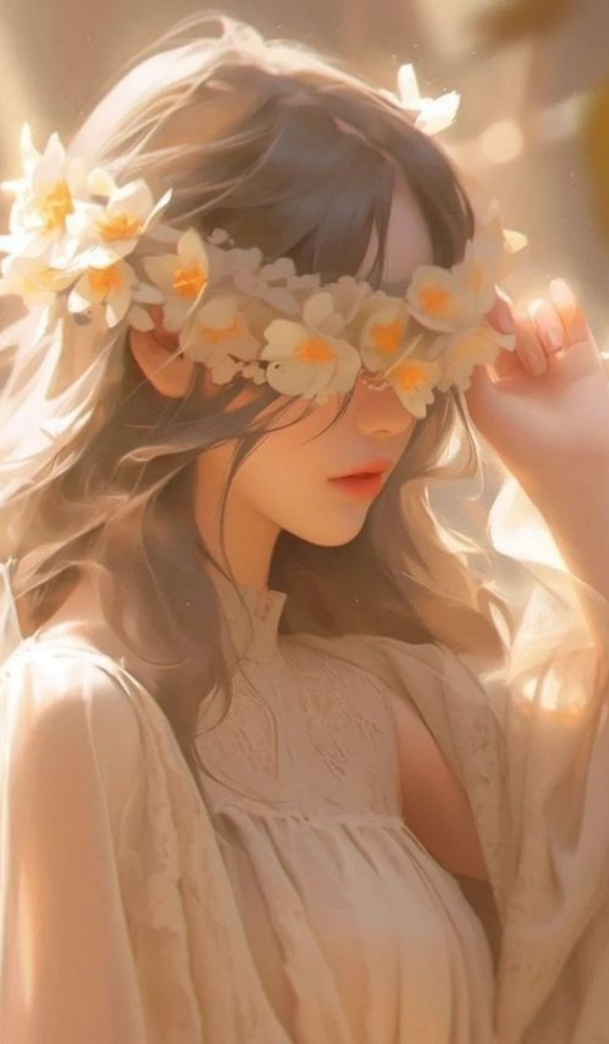This girl is so beautiful
Heloo | I | Am
Melina | Hafizi | Good  bye

My | Mom | Name | Is | Shadi
My | Dad | Name | Is | Mohamad reza
Mohamad reza
Shadi

I like my mom and dad

