Student’s Name: ____________________ Grade: ______________/8
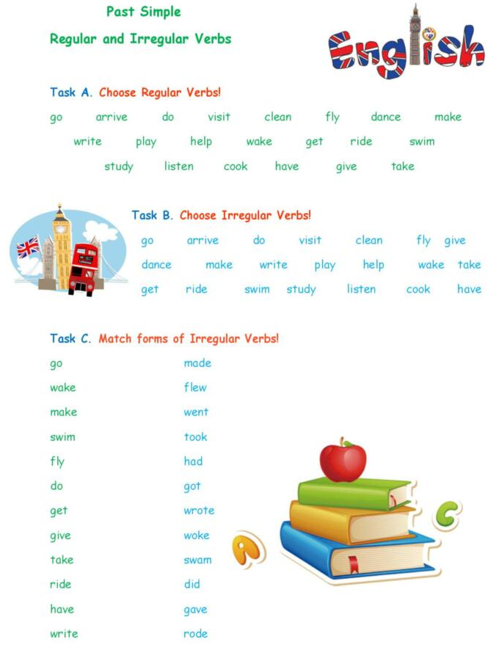
Part A. Put the verb in the past simple tense to fill the gaps.
1. The cat _________________ (escape) from the garden.
2. They __________________ (ride) their bikes.
3. He _________________ (try) to start the car.
4. We __________________ (enjoy) the funfair a lot.
5. Tell me, what __________________ (happen)?
6. She ____________________ (stop) at a zebra crossing.
7. I _______________ (carry on) working until late.
8. Alfie _______________ (fail) his driving test again.
Part B. Correct the mistakes in these sentences.
1. Did he jumped a red light?
_________________________________________________________________________
2. They no liked the film.
_________________________________________________________________________
3. We planed to go on a trip round the US.
_________________________________________________________________________
4. You didn’t kill it, do you?
_________________________________________________________________________
5. The door opened and we went in.
_________________________________________________________________________
6. Played you tennis last year?
_________________________________________________________________________
Part C. Unscramble the words and make proper changes to write a correct sentence.
- buy / a jeep / last week/ My father/.
____________________________________________________________________

- wash/ last night/ I/ my hair/. (-)
____________________________________________________________________
- Jane / send / four e-mails / to Lisa/ When/?
_________________________________________________________________________
- We / visit / our friends / yesterday evening/?
_________________________________________________________________________

